**4. Results and Discussion**

Whilst Drones are not the most popular method for extending wireless networks these can prove to be useful in areas where natural disasters occur. Nevertheless, it would be unwise to ignore them simply because disasters are unlikely to happen. Several analysis procedures were conducted to determine the implication of this network setup. The main goal behind this implementation is to find out what protocol would be most usable in such disaster scenes when using a drone with a Raspberry Pi on board acting as the access point.

Prior to the effective deployment of any network, it is necessary to conduct a performance evaluation of the proposed system.

In the following, specifically explored four key metrics for this type of system: (i) coverage area, (ii) transmission rate, (iii) signal strength and (iv) Efficiency

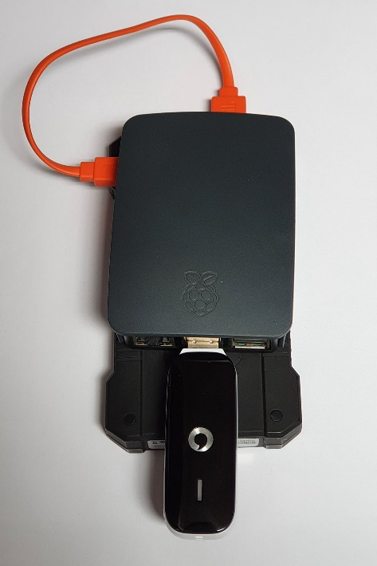

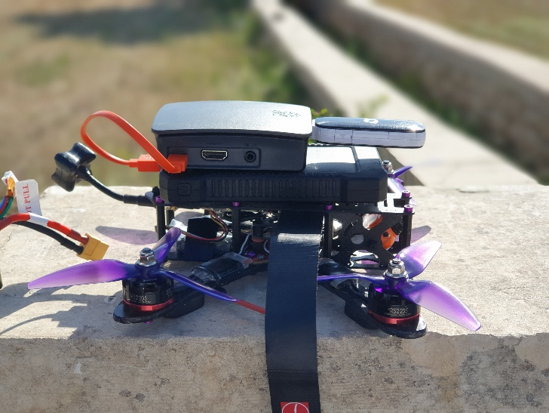

**4.1 Coverage range**

In this section, I am going to present both the theoretical study of the coverage area that the drone can reach with a raspberry Pi onboard and the experimental results obtained while performing the setup in the real-world scenario. For this theoretical study, it was assumed that the scenario deployed will be open area scenario and without any obstacles or any other source to interfere with the signal, hence having a permanent line-of sight (LOS) between the Access point located on the drone and the communication endpoint.

Theoretically both the 802.11a and the 802.11g have a maximum network bandwidth of Mbps. The 802.11a standard employ the single input, single output (SISO) antenna technologies, and the indoor/outdoor ranges from 35m to 125m for 5GHz operating frequency(Ramia Babiker Mohammed Abdelrahman et al,2015). The 802.11a is also less prone to interference compared to with 802.11g due to the high operating frequency of 5GHz. On the other hand, the 802.11g standard which operates at 2.4GHz frequency and bandwidth of 20MHz. This standard uses the Orthogonal Frequency Division Multiplexing(OFDM) or Direct-Sequence Spread Spectrum (DSSS) modulation schemes. This protocol also employs the single input, single output (SISO) antenna technologies, and its indoor/outdoor range are from 38m to 140m respectively

After this researched theoretical study, the coverage area was also evaluated in the real-world experiment as described before. Two experiments were accomplished in which the Raspberry Pi board acted as an access point using both the protocols which were selected.

Additionally, there are some notable difference which were expected to be seen between the expected theoretical values and the actual attained figures. This is expected and can be explained by many elements influencing the real experiment: drone instability, interference caused by the drone’s radio frequency, atmospheric conditions, etc

In the first experiment, the 802.11g(2.4Ghz) protocol is used which the results obtained from the Ekahue site survey are as expected. The results obtained from the real-world are like those found in the theoretical study where at a distance of 44m the receiver(laptop) was still able to have connectivity with the Raspberry Pi network without losing much signal strength. After the same test is repeated with the 802.11a(5Ghz) protocol.

Comparing the signal coverage results obtained from both modes of operation, it is clearly detected that 2.4Ghz protocol has longer range compared with the 5Ghz. The results shown in fig shows the coverage maps for both protocols. This increase in the signal coverage for the 802.11g protocol is also reflected in a better throughput, this will be discussed in the next subsection

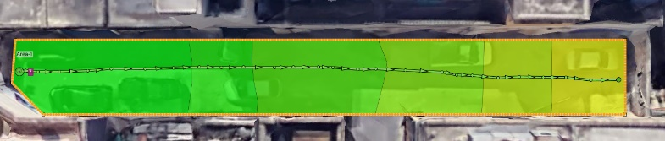

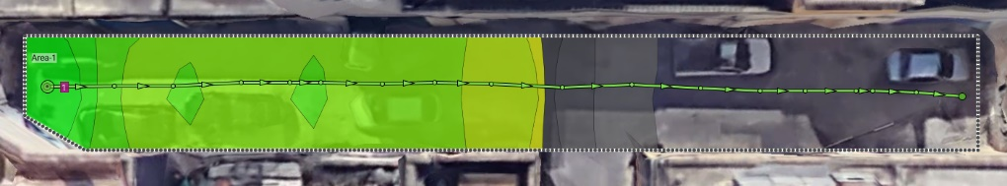

**4.2 Transmission Rates**

In order to evaluate the performance of the protocols in terms of throughput both the theoretical studies that will be carried out and the experimental results obtained while performing the setup in the real-world scenario. From the study performed by (Vouzis, P., 2020) the Raspberry Pi 3 b+ was tested against the previous model the Raspberry Pi 3B using iPerf version 2. The results from this test identified that  3B+ achieves around 1.5x more iPerf bandwidth than the 3B model on the 2.4 GHz protocol which calculated to an average value of 64.5 Mbps as shown in fig 5. For the 5GHz protocol this cannot be compared as the older version the Raspberry Pi 3B does not support 5GHz.

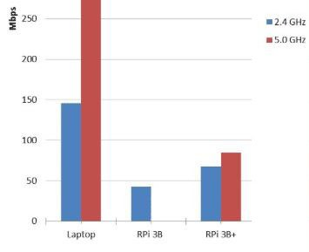

This behaviour was confirmed by a second experiment, which was performed in a real deployment. In order to evaluate the performance of the 802.11a and the 802.11g protocols in the real-world experiment in terms of throughput, iPerf version 3 is used. This tool is the default tool used by Ekahau site survey software which is also the latest iPerf version available. The iPerf3 tool is used for several constant-bit-rate transmissions lasting 20s each,

between the Raspberry Pi and the testing endpoint.

In the first experiment, which was carried out under controlled conditions,

The results obtained for the 802.11g(2.4Ghz) protocol proven the network to have a fixed transmission rate of 66-68 Mb/s during the entire test. Comparing this result to what was obtained from the theoretical study tone can identify that these values are almost identical.

The results which are obtained from the 802.11a(5Ghz) protocol can be seen to be different to those from the 2.4Ghz. One can instantly identify that the transmission rate starts to decrease at a distance of 22meters. From that point onwards the throughput can be seen to decrease the further away you are. The results obtained in the experimental aerial WIFI network are included in Table 3. Observe that the performance in terms of throughput of the 802.11g was notably higher than that attained by the 802.11a protocol at long distances. On the other hand, when keeping in mind short range the 802.11a protocol has faster transmission rates

In the two experiments in which the Raspberry Pi board acted as an access point for both protocols, it is important to note that the attained values are far from those measured under controlled conditions, so the drone motion, a possible radio interference caused by the drone’s chassis, other networks, or the environmental changing conditions seem to have a remarkable impact on the networks performance. In the same way, the results for the 802.11g protocol are similar to those obtained in (fig 4), however for the second test with the 802.11a protocol it seems to have been affected by some interference as one can see there was a place where the transmission rate was very low compared to the rest of the results.

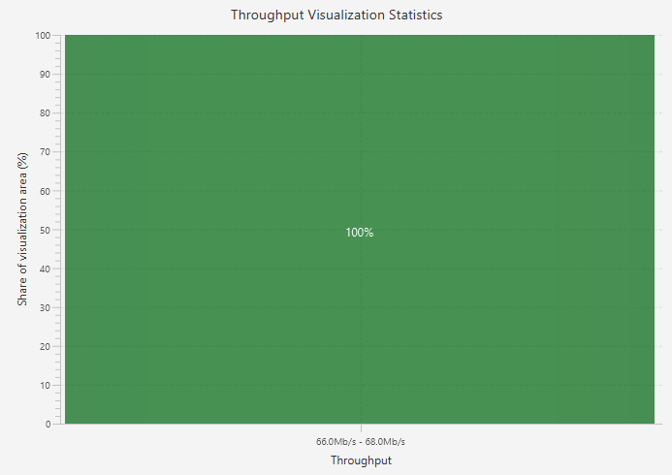

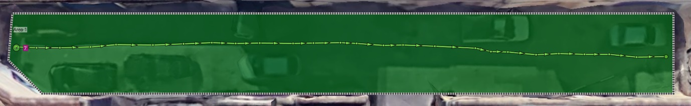

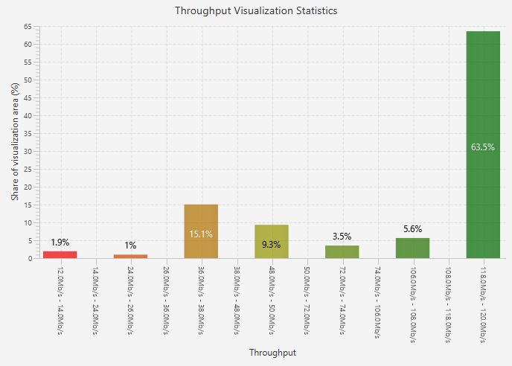

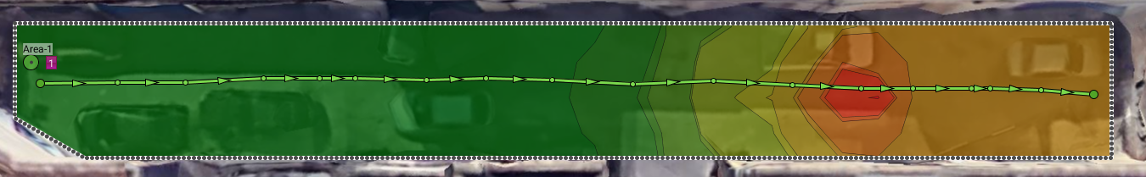

**4.3 signal strength**

Theoretically the Raspberry Pi should have a maximum signal of 31 dBm, this was identified by using iwconfig command on the terminal which displayed the Tx-Power.

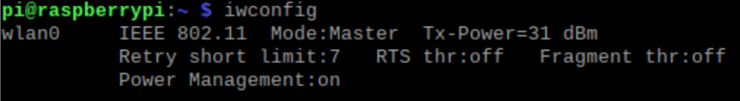

Some notable difference is expected to be seen between the theoretical values obtained from the terminal and the actual attained figures obtained in the tests due to having some radio interference caused by the drone’s chassis, transmitting loss or interference from other networks which seem to have an impact on the results as occurred in the above tests results.

In order to test the signal strength of the protocols in terms of dBm the survey which was carried out previously for the coverage range was used Figures 3 and 4, From this survey the signal strength map was displayed.

One can observe the performance decreases the further away you are from the Access point.

According to the test results for the 802.11g protocol the maximum signal is 36dBm which is close to what was provided theoretically but as predicted the signal strength was still not equal to what is provided in the theoretical result due to some loss which occurs when transmitting.

The signal strength results obtained from the 5Ghz protocol identifies that the maximum signal strength is also 36dBm which is the same strength from the previous protocol. This value was predicted to be identical due to using the same Raspberry pi device as the Access point for both tests so changing the protocols should not affect the transmitter power of the device.

Comparing the signal strength results obtained from both the tests, it is clearly detected that 802.11g protocol has a more acceptable result throughout the whole area. The signal strength can be seen decreasing gradually to a lowest value of 66dBm at a distance of around 44m. This value is a reliable signal strength which is enough for such as voice over Wi-Fi and non-HD video streaming. The results obtained for the 802.11a protocol proven to be different, the signal strength can be seen to be mostly focused towards the beginning of the area. The signal strength can also be seen decreasing at a more frequent rate. This can be seen taking affect at a distance of 22meters which is similar to where the transmission rates also started decreasing throughput.

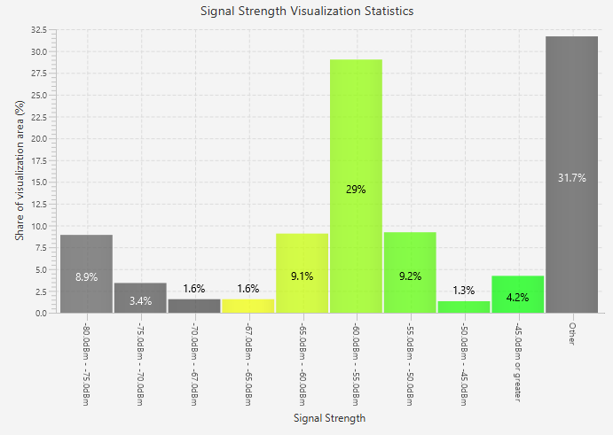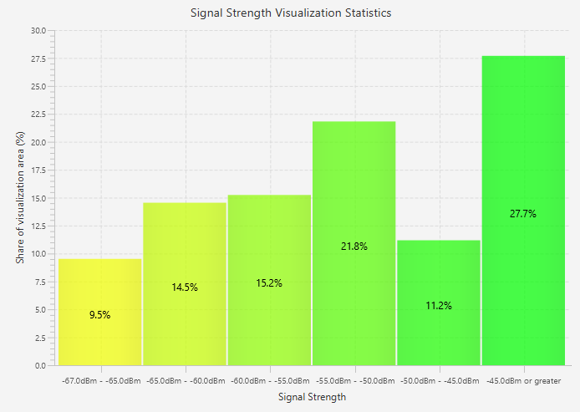

**4.4 Energy Efficiency**

The last important characteristic of the onboard system is tested on is its current consumption. By determining the raspberry pi’s current demand under the different operational modes and supporting several traffic loads, its battery can be accurately dimensioned. This is a crucial factor due to the strict load’s weight restrictions which is imposed by drones. Due to this I carried out a theoretical study of the instantaneous current consumption of the Raspberry Pi board for both the 802.11a and the 802.11g protocols.

These measurements were taken at for both the protocols at an, idle state while having the hostapd WIFI config file running in the background. According to the tests done by (MATT, 2020)

The Raspberry Pi 3b+ at idle with WIFI connection consumes 0.55A.

If this value is multipled by the voltage of the Raspberry pi uses to power on you end up with 0.55A*5V =2.75w

100Ah * 3.7v = 370 Wh

370Wh/2.5w = 134hrs

Data rate

The data rate is the maximum theoretical value that a channel can transmit bits **in a** second if there were no losses or interference the wireless link, Date rates are related to the capabilities of the physical-layer connection capabilities. The modulation techniques, channel bandwidth, coding rate, number of spatial streams, guard interval size, etc. all play a role in the amount of data rates possible.

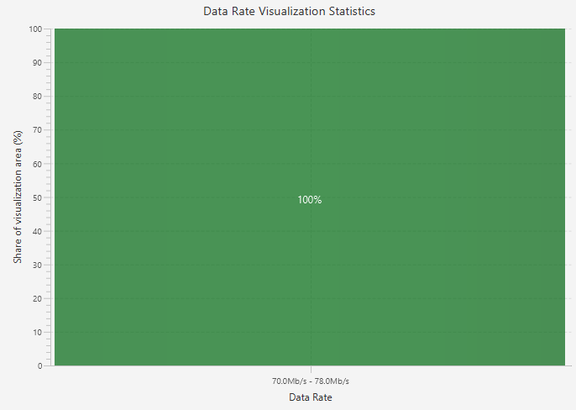

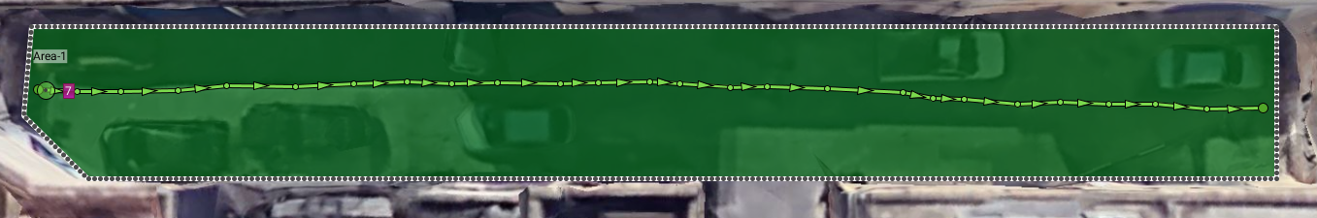

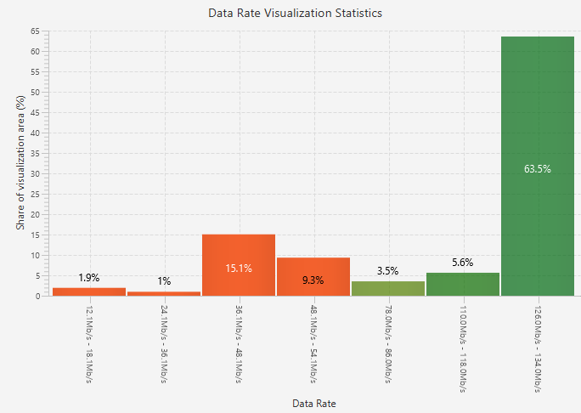

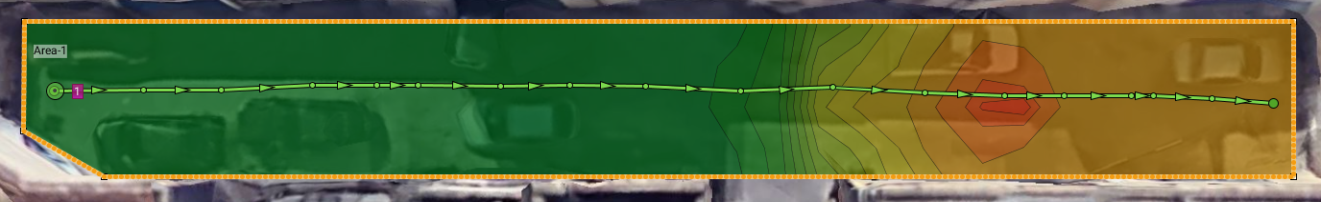

The 802.11g protocol which is shown in fig 6 and 7 has a data rate of between 70 and 78 MB/s this value is found to be the throughout the whole area of the survey.

The 802.11a protocol on the other hand has a maximum data rate of 126 to 134 Mbps according to the chart in fig 8 but unlike the 2.4GHz this changes the further away the receiver is from the access point as highlighted in fig 9. In the survey this is clear visible

However, in the real world, there will always be interference and losses which will result in a lower bit rate than what is shown. The throughput is a practical value that the wireless link can achieve.

References

Ramia Babiker Mohammed Abdelrahman et al.,” A Comparison between IEEE 802.11a, b, g, n and ac Standards” 2015

Vouzis, P., 2020. *Raspberry Pi 3B+ Iperf Wifi Performance*. [online] NetBeez. Available at: <https://netbeez.net/blog/raspberry-pi-3b-iperf-wifi-performance/>

MATT, 2020.Raspberry Pi Spy. *Raspberry Pi Power Consumption Data - Raspberry Pi Spy*. [online] Available at: <https://www.raspberrypi-spy.co.uk/2018/11/raspberry-pi-power-consumption-data/>